ANA 6 E a  
i ‘ a  
Ee EE  
as Per gp ena peor

CATHOLIC HIGH SCHOOL  
MID-YEAR EXAMINATION (2019)  
PRIMARY SIX  
ENGLISH LANGUAGE

PAPER 2 (LANGUAGE USE AND COMPREHENSION)

RBROOKLETB

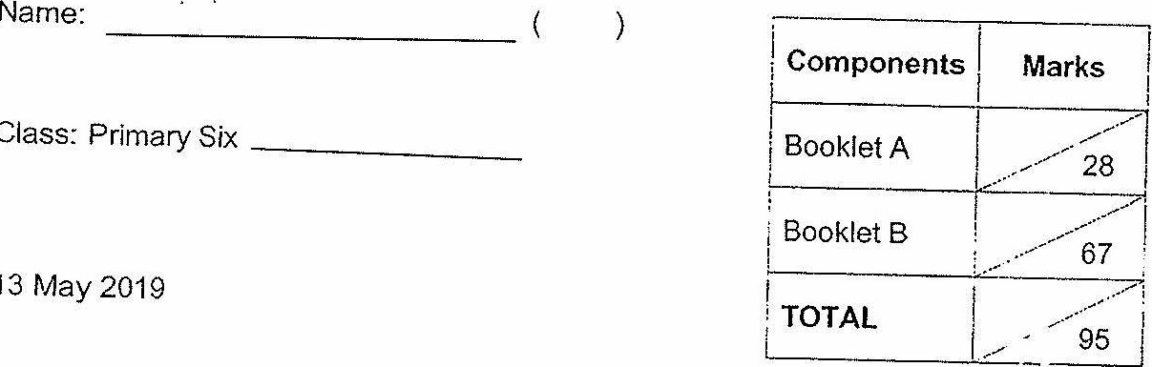

Class: Primary Six _________

13 May 2019

oz Questions  
(67 Marks)

Parent's  
Signature: _________

Total Time for Booklets A and B: 1 hour 50 minutes

INSTRUCTIONS TO CANDIDATES

Do not open this booklet until you are told to do so.

Follow all instructions carefully,

Answer all questions.

Write your answers in this booklet.

This booklet consists of 8 printed pages excluding the cover page.